Below are some sentence, however they are written incorrectly. Fix the sentences by moving the words around to the right spots!
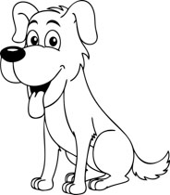
Dog runs. The

The rolls dog around.

Colour in the two dog pictures when you finish!

The sits dog.
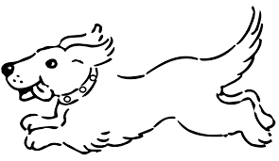

The dog park to the goes.

