Read the passage below and answer the questions about it.

There is a new water park in town. We go there on the first day of summer holidays. It has pools and water slides, of all different sizes. The slides are scary at first but then you learn to love them!
One of the pools makes its own waves. All the kids pretend to surf on the waves, it is really fun.

The water park can get crowded because there are so many kids and adults.

We really like the ice cream at the snack bar. They also sell donuts!
We all love the new water park and can’t wait to go there again this summer.

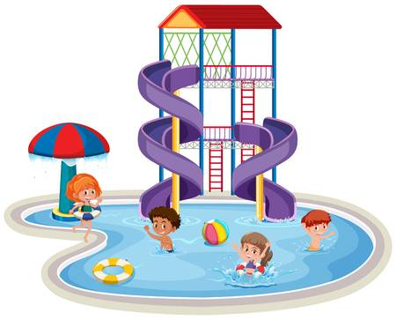

- What is new in town?

- What is scary at first?

- What do they like at the snack bar?

- Why does the water park sometimes get crowded?

