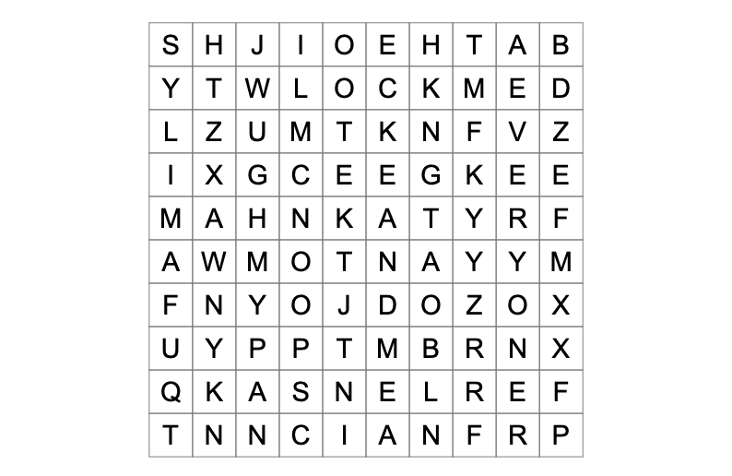
Search for the hidden words!
Cross out each word as you find them.

- Ant
- Lock
- Boat
- Spoon
- Bath
- Everyone
- Family
Great Job! Now write 7 sentences, using these words! One of the words, per sentence..

1.

2.

3.

4.

5.

6.

7.

