Thomastown West Community Hub
Homework Club
- Copy out the alphabet on the line bellow either by typing it or writing it with a pencil.

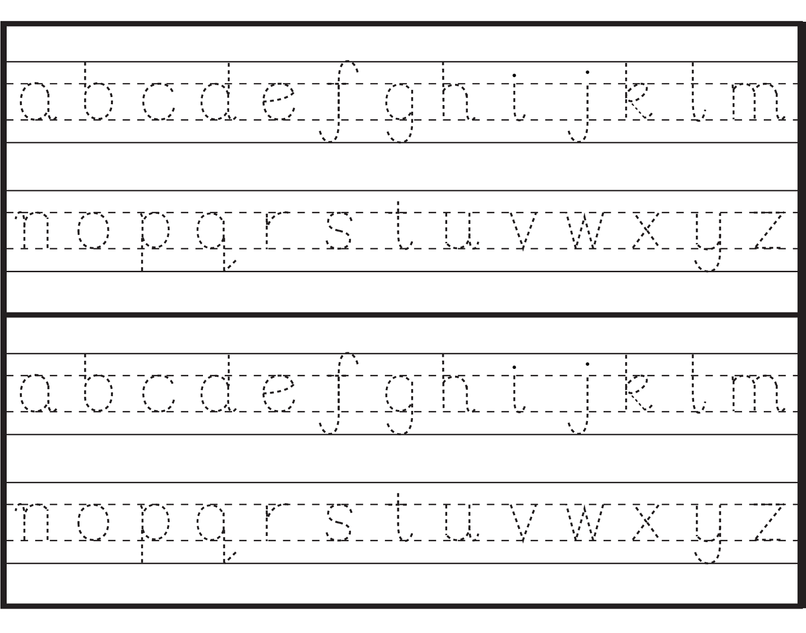

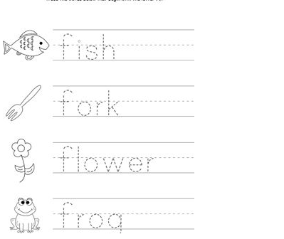
2.Copy each word out on the line next to it by writing or typing

- Write the name of the picture you see

