How many butterflies do you see? Count each butterfly and write down the number next to it!

How many butterflies do you see? Count each butterfly and write down the number next to it!

How many cars do you see? Count each car and write down the number next to it!
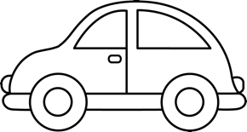
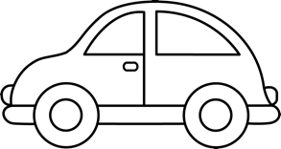

How many cars do you see? Count each car and write down the number next to it!

Great Job! Now in the box below, draw 5 flowers!

Great Job! Now in the box below, draw 10 of any object you like! Get creative!

