Here is a fun game you can play with a friend or a parent. All you need are 2 dice!
Roll the dice and fill in the columns like the example in the first row.

- Roll the dice
- Draw the dice you rolled
- Write down the two numbers in an addition sentence
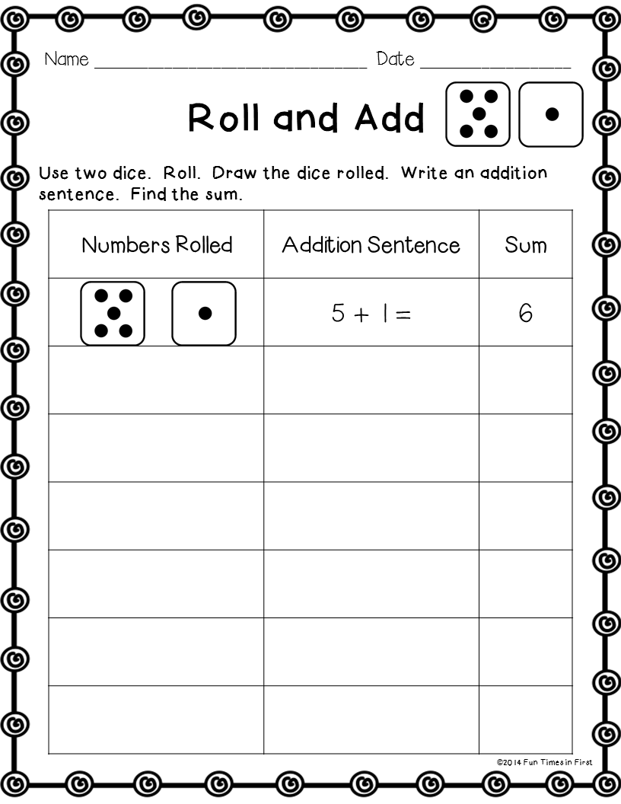
- Write down the answer

