Read the passage below and answer the questions about it.

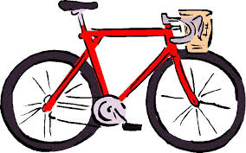
Julie has a new bicycle. It is bright red and shiny.
It was a birthday gift from her parents. They hid it behind a bush in the backyard to surprise Julie!

When Julie looked behind the bush and saw the bicycle, she jumped for joy. It was just what she wanted. She gave her parents a big hug.

Julie loves her new bicycle and she loves her parents.

- What colour is the bicycle?

- Who was it a gift from?

- Where was it hidden?

- What did Julie do when she saw the bicycle?

