The following words have been jumbled! Write them out correctly.
chsool

lpya

osueh

rdie

btale

rweolf

sohe

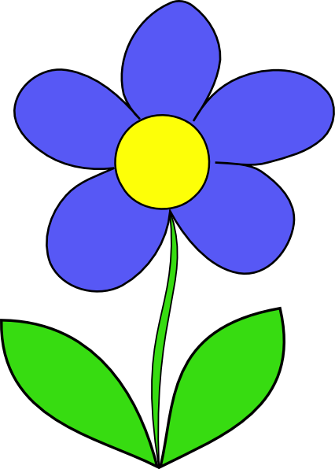
kocs

ookb

