TELLING THE TIME!

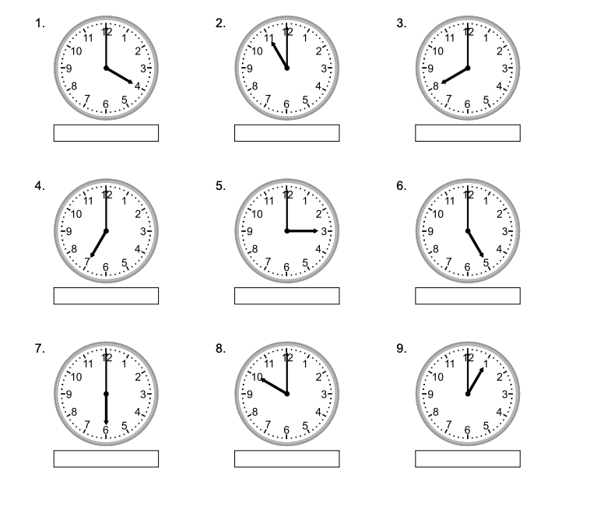
What’s the time on each of these clocks? Write your answer under each clock!

