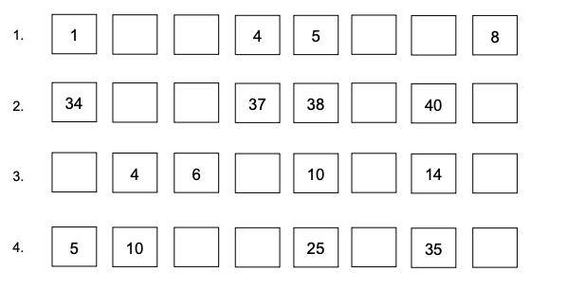
Fill in the missing numbers by figuring out the pattern!

