Circle the word that is spelled correctly.

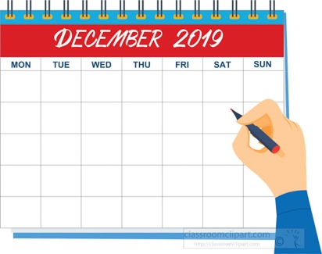 | Calandar, Colonder, Calander, Calendar
 | Classe, Clas, Class
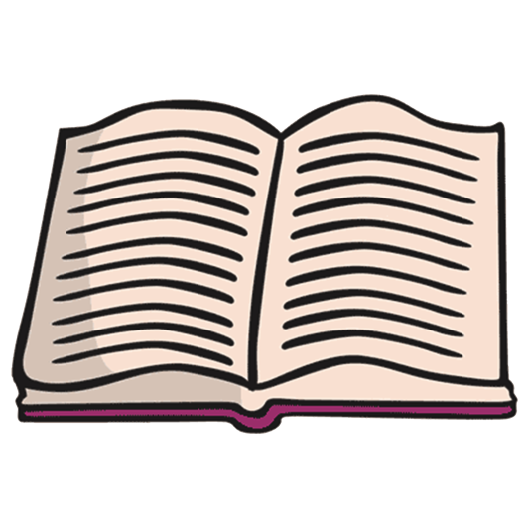 | Buk, Book, Booke
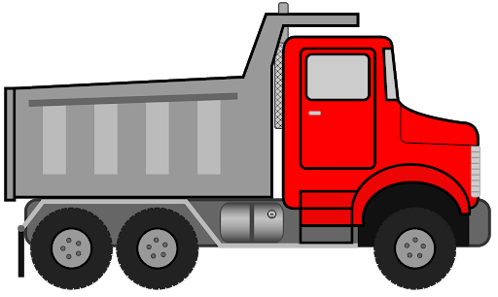 | Trock, trucc, truck, trukk
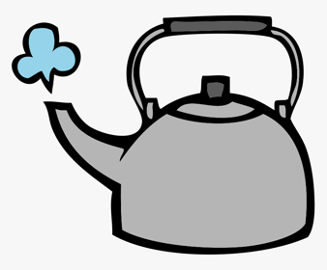 | Ketile, Ketle, Kettle, Ketel

