Fill in the missing numbers by figuring out the pattern. The first one is done for you.
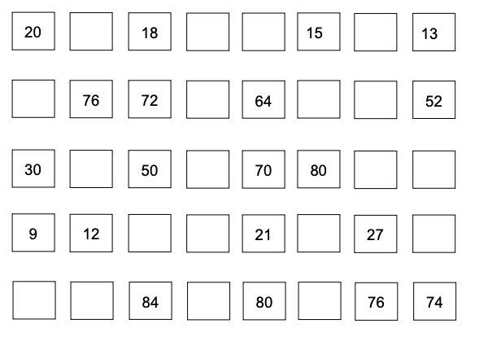

19 17 16 14

