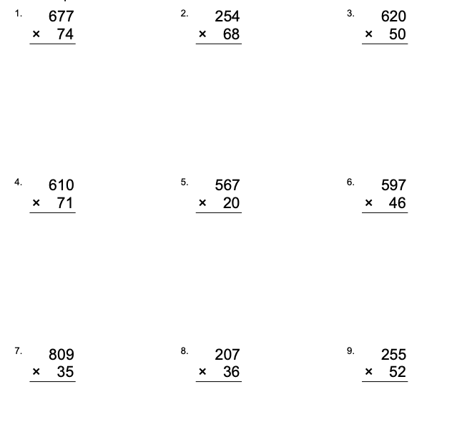
Using the long multiplication method, work out these equations.

