Circle the picture on each line that has the same meaning as the word
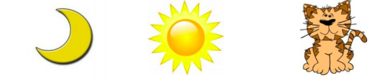
Cat

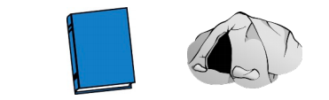

Book

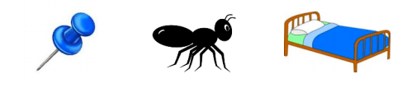

Pin

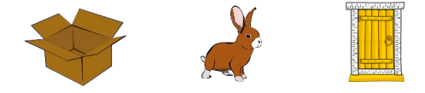

Box

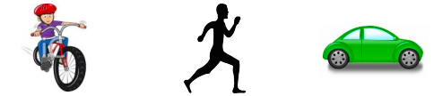

Run

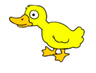
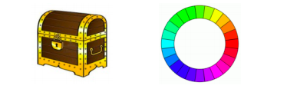
Duck

