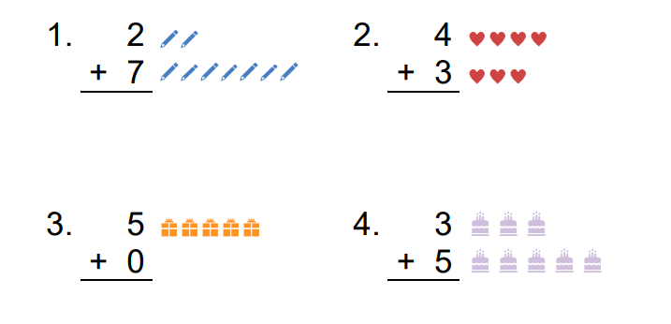
If you count all the objects, you will get the answer! The first one is done as an example.

This is a simple way to ADD numbers together.

